Novema kulde as bruker instruks
Side 21
Alarmkoder.
Feilkode Årsak Løsning Action Reset alarm
rele

Check the correct supply of water to the cylinder; Turn the machine off and clean: the cylinder, the level control and the fi ll electrovalve
Turn the machine off and clean the water conductivity measuring electrodes;
If the problem persists, change the source of the supply
water or install a suitable treatment system (demineralisation, even partial);
The problem will not be resolved by softening the supply water
 | high conductivity of the supply water

manuell | only if EE appears during AR

total auto
shutdown available aktiv
contradiction of the fl oat

 | - activation of safety thermostat  - Klixon activation  - the thp output is open | Check the earth current of the heaters, and if replace necessary.  Manually reset the Klixon  Problem dependent mainly on operation without water;  Turn the machine off and, once it has cooled down, reactivate the thermostat on the cylinder cover after having cleaned the cylinder and the level control, checking the efficiency of the components;  Check that the electrical and water connections are in order and that the machine is supplied correctly;  It may be necessary to replace the PTC sensors if installed | not available | active if Et remain in order at least a minute.

 | autotest failed; probable problems  in: supply water, level control or electrovalve | Ensure that the machine is supplied with water;  Turn the machine off and clean the level control and the fi ll valve | Manuell | active only on the second EP or after EE during AR

 | - electrical power not available; on machine start-up no steam is produced or the water is not preheated  - fl oat locked in high level position. | With the machine off and disconnected from mains power  supply, check that there are no defective of malfunctioning  electrical connections | Manuell | active only on the second EP or after EE during AR

 | No water | Check that the supply pipe from the water supply to the humidifi er and the internal pipe is not blocked or choked and that the pressure is suffi cient (1-8 bar);  Check the operation of the fi ll electrovalve; Check that the steam supply does not have to work against excessive back-pressure, preventing the flow of water into the cylinder due to gravity;  Check that the steam supply pipe is not choked or that there are no pockets of condensation | humidifi er disabled  after waiting 10  min the alarm is automatically reset and a new fi ll cycle is  attempted | manual or automatic (if  after waiting  10 min the water supply returns)

Novema kulde as bruker instruks
Side 22
Feilkode Årsak Løsning Action Reset alarm rele

 | formation of foam  in the cylinder  during boiling | The formation of foam is usually due to the presence of surfactants in the water (lubricants, solvents, detergents,  water treatment or softening agents) or an excessive concentration of dissolved salts. Drain the water supply line;  Clean the cylinder | signal only Manuell not active

 | high water  conductivity pre-alarm | Check the conductivity of the supply water;  If necessary, install a suitable water treatment system;  The problem will not be resolved by softening the supply  water | humidifi er disabled | auto  active  availbale

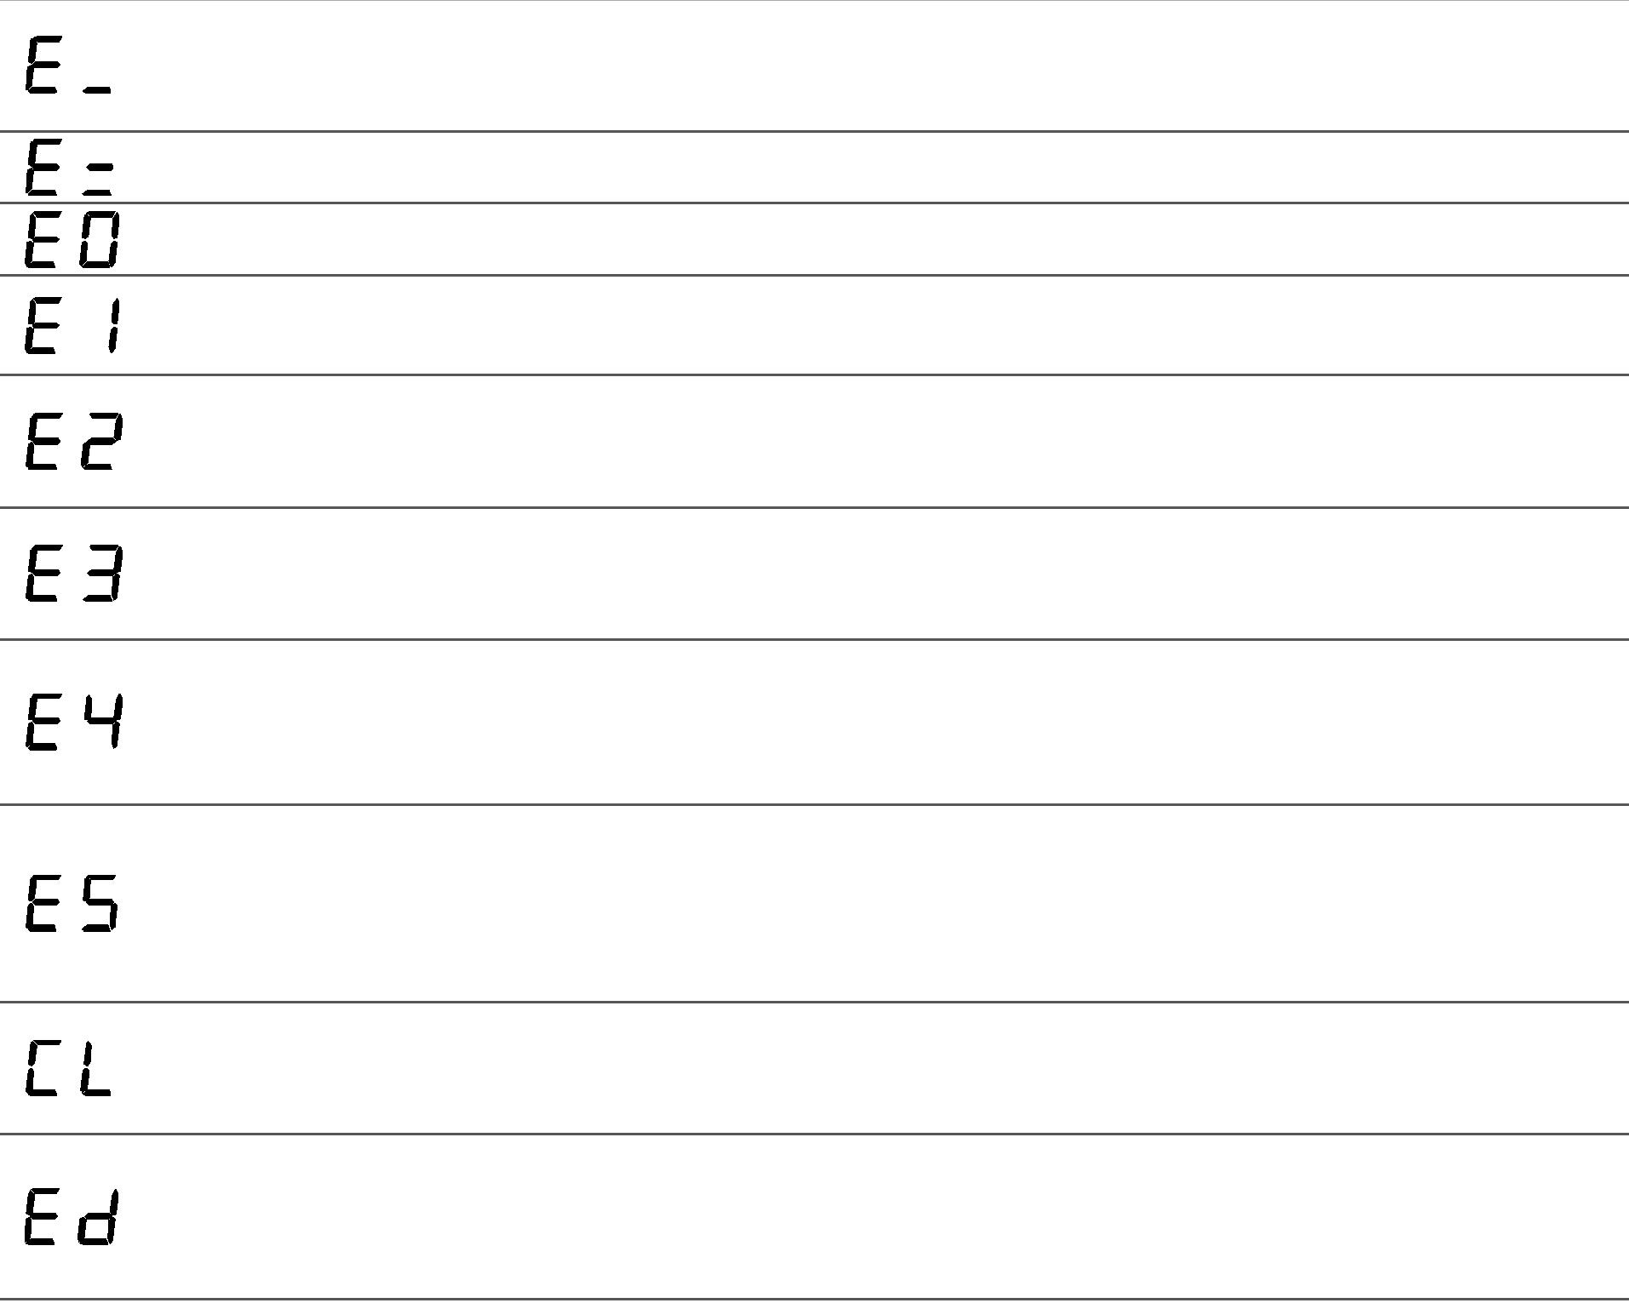
low ambient humidity low temperature in T control)
signal only auto
active
availbale
check the operation of the probe and the limit set by
parameter P3
internal memory error
Contact the CAREL service department humidifi er reprogram
active
disabled CAREL
not active
manual hour counter reset
hour counter saving disabled
hour counter error Reset the hour counter (see Resetting the hour counter)
humidifi er disabled
room probe not connected
auto
active
available
Check the connection of the probe and the setting of parameter A0 for ON/OFF confi guration (see Reading and programming the parameters)
humidifi er disabled
outlet probe not connected (if featured)
auto
active
available
Check the pre-heating operation and the setting of parameters b1, b2, b3 (see Reading and programming the parameters);
Check the connections to the terminal block on the cylinder cover
pre heating disabled
NTC probe for measuring the water Temperature not connected (if featured)
auto
active
available
Check the pre-heating operation and the setting of parameters b1, b2, b3 (see Reading and programming the parameters);
Check the connections to the terminal block on the cylinder cover
regular maintenance signal
sigmal only manual not active
Stop the machine and carry out a complete maintenance routine on the humidifi er, resetting the hour counter (see
Resetting the hour counter)
active on the second “Ed”
manual
see
procedure “AR”
no drain pre-alarm or filter blocked
Check the drain valve/pump;
Check if the pipes or the manifold are blocked; Check if the level sensor is faulty or the pipes are blocked;
The filter inside the boiler may be clogged.
high outlet auto
humidity Check the operation of the outlet probe signal only availbale active
user parameter error
With the machine off check that there are no defective or malfunctioning electrical connections
humidifi er disabled
parameters active
reprogram
 | high ambient humidity  (high temperature  in T control) |  | Check the operation of the probe and the limit signal only auto  active  set by parameter P2 availbale
 |  | boiler full of water with no humidifi cation  demand pre-alarm | Check if the fill valve is leaking; not  Check if the high level sensor is dirty. signal only auto  available active

Novema kulde as bruker instruks
the humidifier does not turn on
the humidifier does not start operation
the humidifier wets the duct
Side 23
Feilsøking
Problem Årsak Løsning

- no electrical power;
- external switch of the humidifier in position 0 (open);
- control connectors badly connected;
- broken fuses;
- transformer fault
- remote ON/OFF contact open (relay/terminals AB – AB or 7I – 8I);
- the humidistat has not been connected correctly;
- humidistat fault
- control signal not compatible with the type set
- value measured by the probe/s higher than the corresponding set point
- too high steam inlet counterpressures;
- inlet filter to the clogged cylinder;
the humidifier loads up water without producing steam
- limestone in the supply tank;
- drain solenoid valve malfunction
- thermal-magnetic overload switch is underrated
- over-current at the electrodes
- the distributor is not installed correctly (too near the top of the duct or the condensate return is blocked);
- system over-sized;
- humidifier active when the fan in the duct is off
- the humidifier drain is blocked;
the thermal-magnetic overload
switch is activated
the humidifier wets the floor below
- the supply water or overflow circuit has leaks;
- the condensate drain pipe does not bring the water back to the supply tank;
- the steam outlet pipe is not properly fastened to the cylinder
- check the protection devices upstream from the humidifier and the presence of power;
- close the switch on the panel: position I;
- check that the connectors are properly inserted in the terminal block;
- check the condition of fuses F1/F2/F3;
- check that the voltage across the secondary winding of the transformer is 24Vac
- close ON/OFF contacts (relay/terminals AB – AB or 7I – 8I);
- check the external connection;
- replace the humidistat
- set parameters A0, A2-A9 correctly
- check the values of the set point St and P7
- check that the steam inlet pipe is not folded or choked;
- clean the filter;
- clean supply tank;
- check the anomalous presence of 24Vac on drain solenoid valve and/or drain solenoid replacement
- check that the thermal-magnetic overload switch is rated for a current of at least 1.5 times the rated current of the humidifier
- see description for alarm EH
- check that the steam distributor is nstalled correctly;
- decrease the steam production set on the control;
- check the connection of the device (flow switch or differential pressure switch) slaving the humidifier to the ventilation in the duct (terminals AB - AB or 7I – 8I)
- clean the drain in the bottom tank;
- check the entire water circuit;
- check the correct position of the condensate drain pipe in the supply tank;
- check the fastening of the pipe clamps on the steam outlet

